[Book title]

[Tagline] – A short catchy sentence which would summarize the scope of the book; it should sound exciting enough to catch the readers’ attention.

# Audience

*Describe your target reader: what you assume about their knowledge of the topic, related topics, and technical topics generally; why they want to learn the technology; the things they will want to do with it.*

# Mission

* *Define what the topic is and the advantages it offers.*
* *Explain what core issues/challenges this book going to address*
* *The journey that this book will take the readers on. [Use this section to set out a high-level structure for the book – to set out a series of stages that will take the reader to the mission’s conclusion and cover the objectives.]*

# Objectives and achievements

*[5-7 bullet points]. This section will highlight some of the important things that the readers will learn during the course of the book. Every point should sound interesting and useful to the reader.*

# General structure

*Use this section to set out a high-level structure for the book – to set out a series of stages that will take the reader to the mission’s conclusion and cover the objectives. The aim is to develop a more structured book with a modular outline that would be easier for our readers to use. We can do this along the following lines:*

*1.* ***Divide books into approximately 3-5 parts****. These will consist of a few chapters each. They will provide a simple overall structure to the book. This can be as simple as “basics, core content, and advanced techniques”.*

*2.* ***Each chapter should have a clear focus****. Avoiding vague divisions like part 1/part 2 or basic/advanced. Each chapter title should clearly state what aspect of the overall topic the chapter deals with, in language the readers will easily understand.*

*3.* ***Each chapter should divide into approximately 5 sections****. These will all have a clear focus of their own, subdividing the chapter’s topic into subtopics or stages.*

*Each section, chapter, and part should work on its own and flow naturally from section to section. We should assume that some readers will work through the book cover to cover, and others will come in just for specific sections. The book must work for both kinds of readers -- as a tutorial and a reference. Each chapter should have a strong focus and all chapter titles should reflect it.*

*To make things easier for you, I have attached a screenshot that will help you understand the difference between a normal outline and a modularized one.*

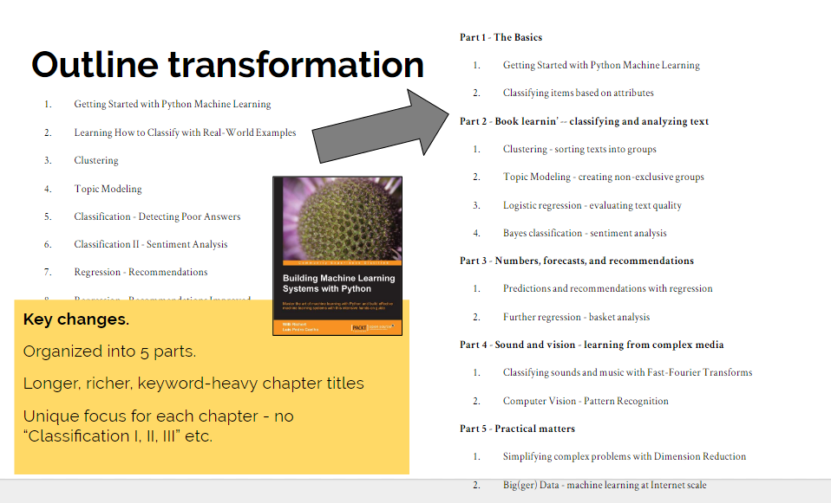

*Before moving into the details, check: is this really giving readers what they want? Does every step move them significantly closer to the goal? Is there anything I could take out, or anything I need to add to enable the reader to complete the mission?* ***Feel free to discuss with your editor if you want a second brain involved.***

# Detailed outline

# **Part 1- [Title]**

# Chapter 1: [Title] - [Pages] pages

## Description

*What is this chapter about?*

## Level

*Relative to the overall scope of the book, is this chapter dealing with BASIC, MEDIUM, or ADVANCED topics.*

## Topics covered

*What technical topics will the reader learn about during this chapter?*

## Skills learned

*What will the reader learn to DO in this chapter?*

# Chapter 2: [Title] - [Pages] pages

## Description

*What is this chapter about?*

## Level

*Relative to the overall scope of the book, is this chapter dealing with BASIC, MEDIUM, or ADVANCED topics.*

## Topics covered

*What technical topics will the reader learn about during this chapter?*

## Skills learned

*What will the reader learn to DO in this chapter?*

# **Part 2- [Title]**

# Chapter 3: [Title] - [Pages] pages

## Description

*What is this chapter about?*

## Level

*Relative to the overall scope of the book, is this chapter dealing with BASIC, MEDIUM, or ADVANCED topics.*

## Topics covered

*What technical topics will the reader learn about during this chapter?*

## Skills learned

*What will the reader learn to DO in this chapter?*

# Chapter 4: [Title] - [Pages] pages

## Description

*What is this chapter about?*

## Level

*Relative to the overall scope of the book, is this chapter dealing with BASIC, MEDIUM, or ADVANCED topics.*

## Topics covered

*What technical topics will the reader learn about during this chapter?*

## Skills learned

*What will the reader learn to DO in this chapter?*

# Chapter 5: [Title] - [Pages] pages

## Description

*What is this chapter about?*

## Level

*Relative to the overall scope of the book, is this chapter dealing with BASIC, MEDIUM, or ADVANCED topics.*

## Topics covered

*What technical topics will the reader learn about during this chapter?*

## Skills learned

*What will the reader learn to DO in this chapter?*

# Chapter 6: [Title] - [Pages] pages

## Description

*What is this chapter about?*

## Level

*Relative to the overall scope of the book, is this chapter dealing with BASIC, MEDIUM, or ADVANCED topics.*

## Topics covered

*What technical topics will the reader learn about during this chapter?*

## Skills learned

*What will the reader learn to DO in this chapter?*

# **Part 3- [Title]**

# Chapter 7: [Title] - [Pages] pages

## Description

*What is this chapter about?*

## Level

*Relative to the overall scope of the book, is this chapter dealing with BASIC, MEDIUM, or ADVANCED topics.*

## Topics covered

*What technical topics will the reader learn about during this chapter?*

## Skills learned

*What will the reader learn to DO in this chapter?*

# Chapter 8: [Title] - [Pages] pages

## Description

*What is this chapter about?*

## Level

*Relative to the overall scope of the book, is this chapter dealing with BASIC, MEDIUM, or ADVANCED topics.*

## Topics covered

*What technical topics will the reader learn about during this chapter?*

## Skills learned

*What will the reader learn to DO in this chapter?*

# Chapter 9: [Title] - [Pages] pages

## Description

*What is this chapter about?*

## Level

*Relative to the overall scope of the book, is this chapter dealing with BASIC, MEDIUM, or ADVANCED topics.*

## Topics covered

*What technical topics will the reader learn about during this chapter?*

## Skills learned

*What will the reader learn to DO in this chapter?*

# Chapter 10: [Title] - [Pages] pages

## Description

*What is this chapter about?*

## Level

*Relative to the overall scope of the book, is this chapter dealing with BASIC, MEDIUM, or ADVANCED topics.*

## Topics covered

*What technical topics will the reader learn about during this chapter?*

## Skills learned

*What will the reader learn to DO in this chapter?*

# Chapter *n*: [Title] - [Pages] pages

## Description

*What is this chapter about?*

## Level

*Relative to the overall scope of the book, is this chapter dealing with BASIC, MEDIUM, or ADVANCED topics.*

## Topics covered

*What technical topics will the reader learn about during this chapter?*

## Skills learned

*What will the reader learn to DO in this chapter?*

# Author Bio

Please fill in your bio to be displayed on our website and other marketing channels.